Realized volatility/variance forecasting

Prerequisite
Read the paper https://fmai.memberclicks.net/assets/docs/Derivatives2021/VolatilityML_Tang.pdf [LT]
This paper is a good starting point to introduce the concepts and notations that we will use during this project.

Introduction

Notations
- $t$ : day $t$
- $n$ : the number of intraday observations (daily observation on close when $n=1)$
- $p_{t-1+i/n}$ : the intraday log-price on day $t$ and interval $i$ ($i=1…n$). Note that $i=0$ corresponds to the previous day close log-price $p_{t-1}$ and $i=n$ corresponds to day $t$ close log-price $p_{t}$.
- $r_{t-1+i/n}=p_{t-1+i/n}-p_{t-1+(i-1)/n}$ is $i$th intraday log return on day $t$ (for $i=1…n$)
- $d$ : daily
- $w$ : weekly
- $b$ : biweekly
- $m$ : monthly

Volatility versus variance
We focus on daily realized variance as this is what impacts the pnl of options. If time allows we can compare the pro/con of predicting vol vs var.

Definitions
- Annualized daily RV: ${RV}_{t}^{d}=252×\sum_{i=1}^{n}{r_{t-1+i/n}^{2}}$
  - When $n=1$ this is simply the daily log return squared and scaled
  - For this work we will only study the cases
    - $n=1$ (corresponds to daily delta hedging at close)
    - $n$ such as we sample the price every 5 minutes (like in [LT])
  - Remark 1: we could use different estimators for the daily variance e.g. Garman-Klass or GKYZ (Garman-Klass-Yang-Zhang).
  - Remark 2: for the intraday observations using 5min intervals will eliminate most of the issues related to microstructure.
- h-day ahead RV: ${RV}_{t}^{t+h}=\frac{1}{h}\sum_{i=1}^{h}{{RV}_{t+i}^{d}}$
  - We are interested in predictions for horizons $h=1, 5, 10, 21$ (daily, weekly, biweekly, monthly)

Features
We will only study a subset of the features in [LT].
- HAR: this will be the benchmark model like in the paper, we will restrict the specification to ${RV}_{t}^{t+h}=β_{0}+β_{d}{RV}_{t}^{d}+β_{w}{RV}_{t}^{w}+β_{b}{RV}_{t}^{b}+β_{m}{RV}_{t}^{m}+ϵ_{t}$ where the various ${RV}_{t}^{x}$ are average daily RV over lags of 1, 5, 10 and 21 days (no need to look at quarterly predictions)
- SHAR: we will use the SHAR model as per [LT] using ${RV}_{t}^{x}$ with $x=d,w,b,m$
- HExpGl: see [LT], we are interested in this model as it introduces the EWMA features

Remark: we will not look at MIDAS (features are similar to HExpGl) nor will we include option implied variance.

Statistical methods

Benchmark models
We will solely look at LASSO regression to start with. This is a simple and well proven method that will enable us to establish a robust benchmark.

Further research
Later you are free to use any statistical or AI/ML method if you can show it performs better. [LT] presents a few such options.

Performance evaluation
In order to assess the model forecast accuracy in the test data we will use several metrics.

Metric 1: RMSE

$$RMSE=\sqrt{\frac{1}{N}\sum_{t=1}^{N}{{\left({\hat{RV}}_{t}^{t+h}-{RV}_{t}^{t+h}\right)}^{2} }}$$
Where
- ${\hat{RV}}_{t}^{t+h}$ are the model forecast
- ${RV}_{t}^{t+h}$ are the realized var

Metric 2: MPE and MA
We will also use the mean percent error MPE:
$$MPE=\sqrt{\frac{1}{N}\sum_{t=1}^{N}{\frac{{\hat{RV}}_{t}^{t+h}-{RV}_{t}^{t+h}}{{RV}_{t}^{t+h}} }}$$
And model accuracy $MA=1-MPE$

Metric 3: Relative $R^{2}$

$$R_{OOS}^{2}(m,b,h)=1-\frac{\sum_{t}{{\left({\hat{RV}}_{t}^{t+h}(m)-{RV}_{t}^{t+h}\right)}^{2}}}{\sum_{t}{{\left({\hat{RV}}_{t}^{t+h}(b)-{RV}_{t}^{t+h}\right)}^{2}}}$$
- $m$ is the model
- $b$ is the benchmark model
- $h$ is the prediction horizon
See 4.8 in [LT]. We will look at out-of-sample $R^{2}$ relative to HAR benchmark.

Remarks
- Although the various models may use intraday data when building the various features, we will only use close-to-close log returns when evaluating the performance (so the performance metric is targeting the close-to-close variance, not the intraday variance, although you may use intraday data up to t to make your prediction over t+h)
- The HAR benchmark will use 1 observation per day (so you will also study the HAR model using intraday data to build the RV features and see if it performs better to predict the close-to-close variance)

Data
You will need 5-minutes bar data (open, high, low, close) for the target universe (see below) and their front month futures.
HKUST will need to buy the data if needed (we can’t share our data)
It is critical that the data you will be using are price adjusted (we do not want to have to deal with dividends, rolls…).
If not possible we will have to discuss how to remediate/mitigate that aspect.
Procedure if you have access to Bloomberg data:
- Download 5min bar intraday data for all indices and their front month futures
- Download daily data for all indices and their front month futures
- Create an adjusted time series corresponding to investing in each front month future and rolling 1 day before expiry
- This time series will be the basis of all the research.

ETF trick
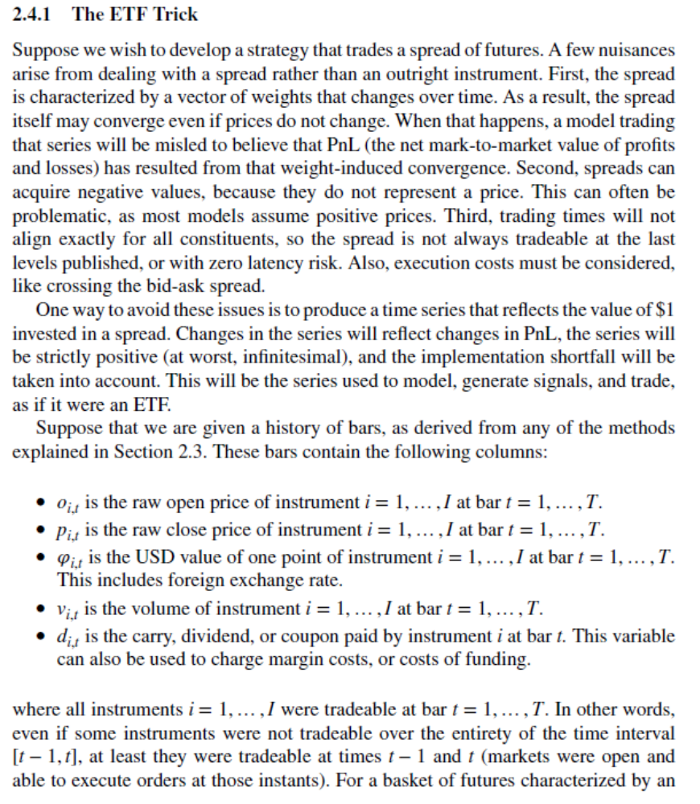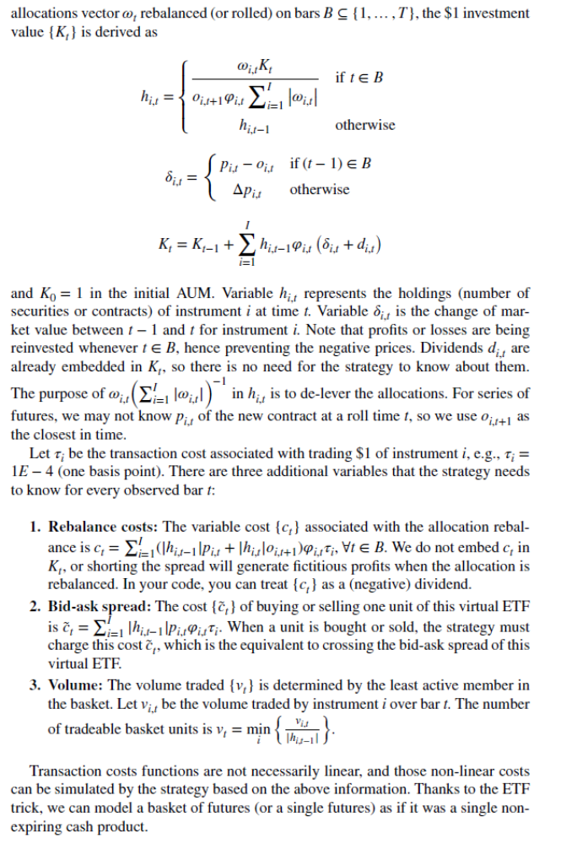
For our case (futures rolls) we can ignore rebalance / spread / volume. The goal is just to create a time series with no undue jumps.

Universe
Major indices (we can adapt depending on data availability, key focus should be on the NA/APAC indices highlighted in bold)
RIC
- .N225
- .KS200
- .HSCE
- .TWII
- .AXJOD
- .HSI
- .TOPX
- .NSEI
- .SPX
- .NDX
- .STOXX50E
- .GDAXI
- .RUT
- .SSMI
- .FTSE
- .NSEBANK
- .HSTECH
- FXI.P
- .SX7E
- .SET50
Later we may enrich with other assets such as VIX.
You will need to assess which data you have access to for the first session. We will then define training/validation/testing sets.

Objectives
Our objective is to predict close-to-close realized volatility over different horizons (from 1 day to 1 month) and universes.
- [Prerequisite] Assess which data HKUST has access to (universe and intraday data) and define training/validation/testing periods.
- [Benchmark] Build HAR benchmark model for the target universe. Study its statistical properties for the various indices in universe.
- [Features] Build the other features for HAR/SHAR/HExpGl
- [LASSO regression] Study the performance (versus HAR benchmark) of
  - Enhanced HAR (enhanced = uses intraday data as opposed to daily data)
  - SHAR
  - HExpGl
  - Combination of all features
- [ML] You can then enhance the set of features / model to be able to capture
  - Regime changes: ideally, we want to adapt quickly when there is a change of regime (typically put more weight on recent data when we think such regime will sustain itself over the prediction horizon)
  - Events: will require extra data
The goal is to find robust RV estimators which react quickly to changes of regimes.
You will create notebooks that can ingest the data (csv or other format) and produce all the results/analysis in a standalone way. Try to minimize using nonstandard Python packages.

References
- Main paper: https://fmai.memberclicks.net/assets/docs/Derivatives2021/VolatilityML_Tang.pdf
- Useful discussion: https://quant.stackexchange.com/questions/64096/realized-variance-realized-volatility
- Presentation on HAR/GARCH/Realised GARCH: https://econ.au.dk/fileadmin/site_files/filer_oekonomi/subsites/creates/Diverse_2016/PhD_High-Frequency/3RealizedGARCH.pdf

Read this thread https://quant.stackexchange.com/questions/64096/realized-variance-realized-volatility to understand what we mean by “quickly”

